



Dissertation for MSc
Programmes (ODL)
Project Proposal

Please only complete this form if you intend to take STATS5084P.
About you
Name | Anthony Walker
Student number | 2606307w
Version / Date form submitted | 21/08/23
Programme | MSc in Data Analytics (ODL)
Route | 4 year route
Courses you have already taken  (not required if you are on the standard regular or faster route) | Taken all courses on standard regular route, just over 4 years.

Submission
Desired submission deadline | June submission
Students who select a May submission will be able to graduate in June (provided they have no pending reassessments). Students who submit in June will be able to graduate in November/December (provided they have no outstanding reassessments).

Summary of proposed project
What is the nature of the project?  Tick all that apply. | ☐ Data analysis  ☒ Software (and/or methodological) development

Overview
Summarise the project in around 50 words.
Development of an open-source air quality modelling WebApp, that automates the calculation of air quality modelling inputs for the user to help simplify the process for increased citizen science air quality modelling.

Detailed Description
Give a detailed description of the project in around 200 words.
The project will involve the development of a Python based WebApp, that will be open-sourced, to allow users to conduct air quality concentration modelling without having to format and develop their own air quality modelling inputs.
Most current open-source air quality models rely on the users being able to understand and manually format a number of different geospatial, meteorological, and emission based data after retrieving them from a number of different sources.
The aim with this app is to automate the retrieval, formatting of a number of different air quality modelling inputs, as well as bespoke calculation of some specific geospatial characteristics such as a point specific canyon factor based on surrounding building and road characteristics.
These will then be used in the development of a number of different statistical modelling approaches to provide an air quality concentration output – using existing monitoring data available through APIs. This will allow a secondary exercise of exploring the best modelling approach given the input data with model performance analysis, and also ensure there is a useable output for the end user in the form of tabulated and visualised air quality data.

Data (Data analysis)
What data do you want to use to answer those questions? Describe both the nature and the quantity of data you want to use.
Overview
Give a brief description of your dataset:
Click or tap here to enter text.

Where is this dataset from:
Click or tap here to enter text.

Is the data publicly available? | Choose an item.
If not, do you have permission to obtain and process/analyse the data? | Choose an item.
If the data is not in the public domain, we strongly recommend that you obtain such permission in writing and/or that a three-way non-disclosure agreement is established.
Have you already obtained the data (rather than just have access to it)? | Choose an item.
If not, what do you need to do to obtain the data?
Click or tap here to enter text.

Detailed Description
Please provide as where the data is obtained from, how the data was/is being collected, what observations represent and what information (variable) is available in the data.
Click or tap here to enter text.

Will you be able to provide the data (or a representative subset of the data) so that your analyses can be reproduced by the markers of the project?  You might require to obtain permission for this from the owner of the data.  (see below for confidentiality agreements) | Choose an item.
If not, please explain why this is not possible.
Click or tap here to enter text.
What variables in the data (or what part of the data in more general terms) do you think will help you answer the questions of interest?
Click or tap here to enter text.
What are the data types of these variables? Please also discuss potential issues with data quality and missing values.
Click or tap here to enter text.

Project details (Software / methodological development)
Only complete this section if your project has a methodological or substantial software development component.
Overview
Objective
What will the method and/or software you want to develop allow the user to do? How and in what context can it be used?
Automated air quality modelling webapp. The aim is for users to input/click coordinates and the webapp to provide a calculated air quality concentration, based on open-source geospatial and traffic/fleet/emission profile data. The context will primarily be simplified open-source citizen science air quality modelling.

Methods
Broad Category
Select all that apply:
Regression ☒ Classification ☒ Clustering ☐
Time series ☒ NLP ☐ Deep Learning ☐
Other specialised analysis (Graph/Network analysis etc) please give more details in following box. ☐
Bespoke geospatial analysis to determine air flow distribution and canyon effect given the road direction and surrounding building height.

Please briefly describe your proposed methodology in 50 words
Use Python to produce a webapp that provides a frontend for users to conduct automated air quality modelling, with a backend that calculates geospatial and air quality parameters to feed into an air quality regression or time-series forecasting model.

Detailed Description
Describe in detail what data analytical models and/or methods you will implement in your project.
For the frontend web app development, I will be using Python Streamlit to create the app with a front facing simple user experience. The front end will consist of an interactive map that will allow the user to place marker points to specify the points at which the system will calculate the geospatial air quality model inputs, and calculate the air quality concentration outputs.

For inputs, I will be making use of a number of open-source APIs; Ordnance Survey building and topographical data, NOAA meteorological, and DEFRA air quality monitoring, Fleet and traffic flow characteristics. The OS building and topographical data along with other geospatial characteristics (road layout etc), will be used to calculate an air quality canyon effect factor. This is where the building height and road layout in relation to wind direction disrupts the flow of air, which has an impact on air quality concentrations.
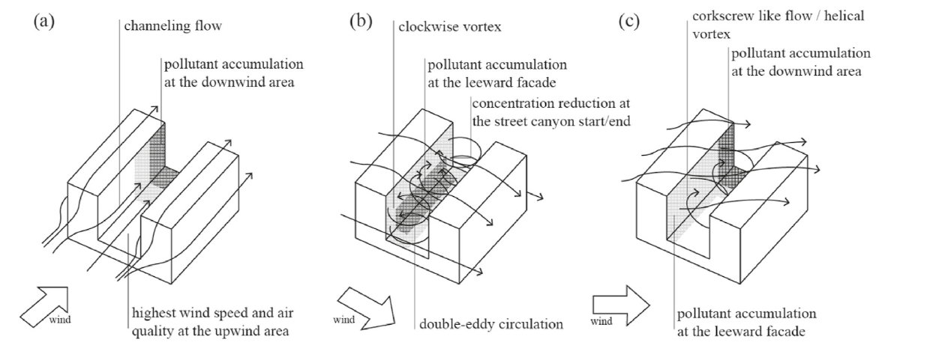
Figure 1 - Estimated flow regimes and pollutant distribution for different orientations of the street canyon (AR > 0.65) towards the prevailing wind direction
I can also determine and automate the calculation of a number of other geospatial characteristics that are known to have an impact on air quality concentrations, such as distance from the roadside kerb, distance to an obstruction, and a major junction for instance.
By automating these air quality inputs, it simplifies the process of air quality modelling for the wider public and citizen scientists, when compared with other existing open-source air quality models.
Once these input parameters have been calculated, I will be exploring a number of different modelling approaches (regression based – Kriging potentially given the geospatial nature) to determine an air quality concentration output. Part of the second half of the project is to determine the best performing modelling approach given the input data, using the air quality monitoring available as training/validation sets.
These outputs can then be formatted and returned to the user tabulated and visualized in the webapp.

Will the project require you to develop novel methodology or adapt existing methods? (This is not required) | Both

If so, describe what methods need to be developed or how existing ones need to be adapted.
An algorithm to calculate point specific canyon factors based on geospatial building height data. Adaptation of existing air quality regression models to incorporate point specific input data.

Prior work
Does software with similar functionality already exist? | Yes
If the answer to this question is “Yes”, please complete the remainder of this section. Otherwise proceed to the next section.
Are such implementations publicly available? | Yes
If so, please provide citations and/or web links.
https://www.epa.gov/cmaq

Please explain how your work will be different to prior work.
Whilst publicly available air quality models are available, these do not automate the input data based on a selected geospatial point. These require the users to have an understanding of, and access to the required input data such as meteorology, emission profiles, topographical building data, road structure etc. The aim of this work is to simplify the data input process for the end user by both sourcing relevant open data directly into the webapp, and also automate the use of this data into a regression model and/or time-series forecasting model to provide the user with a concentration output that is useful – i.e. hourly/annual average.

Connection to programme
What methods and topics covered in the MSc programmes will your project relate to?
Python, regression, tensorflow, time-series, data preparation and processing, big data.

What data analytics methods and topics not covered in the MSc programmes will your project relate to?
Front end python webapp development – streamlit etc.

Software
Which software are you intending to use for the project?
In case of a software development project, list the software your project will depend on.
Overview
What software do you intend to use for the analysis?  Tick all that apply. | ☐ R  ☒ Python  ☐ SAS  ☐ Other (please specify below)
If you project has additional requirements in terms of computational resources (CPU/GPU, memory and/or storage), explain what resources you will use.  (You should complete this field if you plan to make use of software such as use Tensorflow or Spark). | Will potentially use Tensorflow backend – trained model to provide predictions quickly to a user on a front end app.

Detailed Description
What R packages / Python libraries are you likely to use?  (other than standard packages such as ggplot2, tidyverse, pandas or numpy)  Also use this field to list other software you intend to use. | Python – Streamlit, Tensorflow as well as standard DS libraries.
Is there substantial amount of software development required for this project (i.e. the re-implementation of methods, above and beyond using data science libraries) | Yes – front end web app development, and the backend bespoke data sourcing and algorithmic approach to calculating the model input parameters.
Is there any other special software requirements of this project | Not at this time

Ethical approval
Overview
Will your project involve working with human/animal subjects, human/animal material or data about individuals that is not anonymised and not already in the public domain? | No
If the answer to this question is “Yes”, please complete the remainder of this section. Otherwise proceed to the next section.
Can the research and data be considered clinical? | Choose an item.
Have you already obtained ethical approval from the University or another institution? | Choose an item.
Have you already applied for ethical approval from the College Ethics Committee (or in case of clinical data the NHS)? | Choose an item.

Comments
Click or tap here to enter text.

Data Protection (GDPR)
Overview
Will the project involve working with non-anonymised personal data that could be subject to GDPR? | No
If the answer to this question is “Yes”, please complete the remainder of this section. Otherwise proceed to the next section.
Will the data provided to you be provided by an organisation who will benefit from the deliverables of the projects or can you be seen as an agent acting on behalf of that organisation? | Choose an item.
If the answer to this question is “Yes”, please complete the remainder of this section. Otherwise proceed to the next section.
Do you have confirmation (ideally in writing) from the organisation confirming that they will be the data controller under GDPR? | Choose an item.

Comments
Click or tap here to enter text.

Confidentiality
Overview
Is any data you will work with and/or information you will mention in the portfolio confidential? | No
If the answer to this question is “Yes”, please complete the remainder of this section. Otherwise proceed to the next section.
Do you require the University to enter a confidentiality agreement with you and/or the owner of the information and intellectual property in question? | Choose an item.
If so, please provide who would be parties to such a confidentiality agreement. We strongly recommend using a non-disclosure agreement to which you (and not just your employer) are a party as well.
Click or tap here to enter text.

Comments
Click or tap here to enter text.
Risks
Describe the main risks that could prevent you from successfully completing the project.
These risks should be specific to the project (such as data not becoming available or being of a different nature or the complexity of the project getting out of control). How likely are these risks? What would be their impact? What can you do to prevent these risks ore mitigate the effects?
Description of the risk | Likelihood / Impact | Prevention / mitigation measures
APIs become no longer available. | Reasonably unlikely/ large impact depending on API | During initial phase of project, API exploration will try and determine number of alternatives for first choice APIs.
WebApp Framework does not contain component required to complete project | Unlikely / Large impact | Streamlit contains custom component creation within its API, so this can be leveraged but comes with time impact.

Comments
Click or tap here to enter text.

Additional information
If there is any additional information about the proposed dissertation topic you would like to provide to the project team, please use the space below.
Not at this time.

D. Voordeckers, T. Lauriks, S. Denys, P. Billen, T. Tytgat, M. Van Acker, Guidelines for passive control of traffic-related air pollution in street canyons: An overview for urban planning, Landscape and Urban Planning, Volume 207,2021, https://doi.org/10.1016/j.landurbplan.2020.103980.

